Institute of Computer Technology

B. Tech. Computer Science and Engineering

Sub: DS Branch: BDA Class: A

Name: Jatin Patel

Enrolment No.: 23162121029

Sem: 3

Class: A

Subject: DS

Practical: 08

Date: 24/09/24

Write a program in C to create and display a Singly Linked List.

Test Data :

Input the number of nodes : 3

Input data for node 1 : 5

Input data for node 2 : 6

Input data for node 3 : 7

Expected Output :

Data entered in the list :

Data = 5

Data = 6

Data = 7

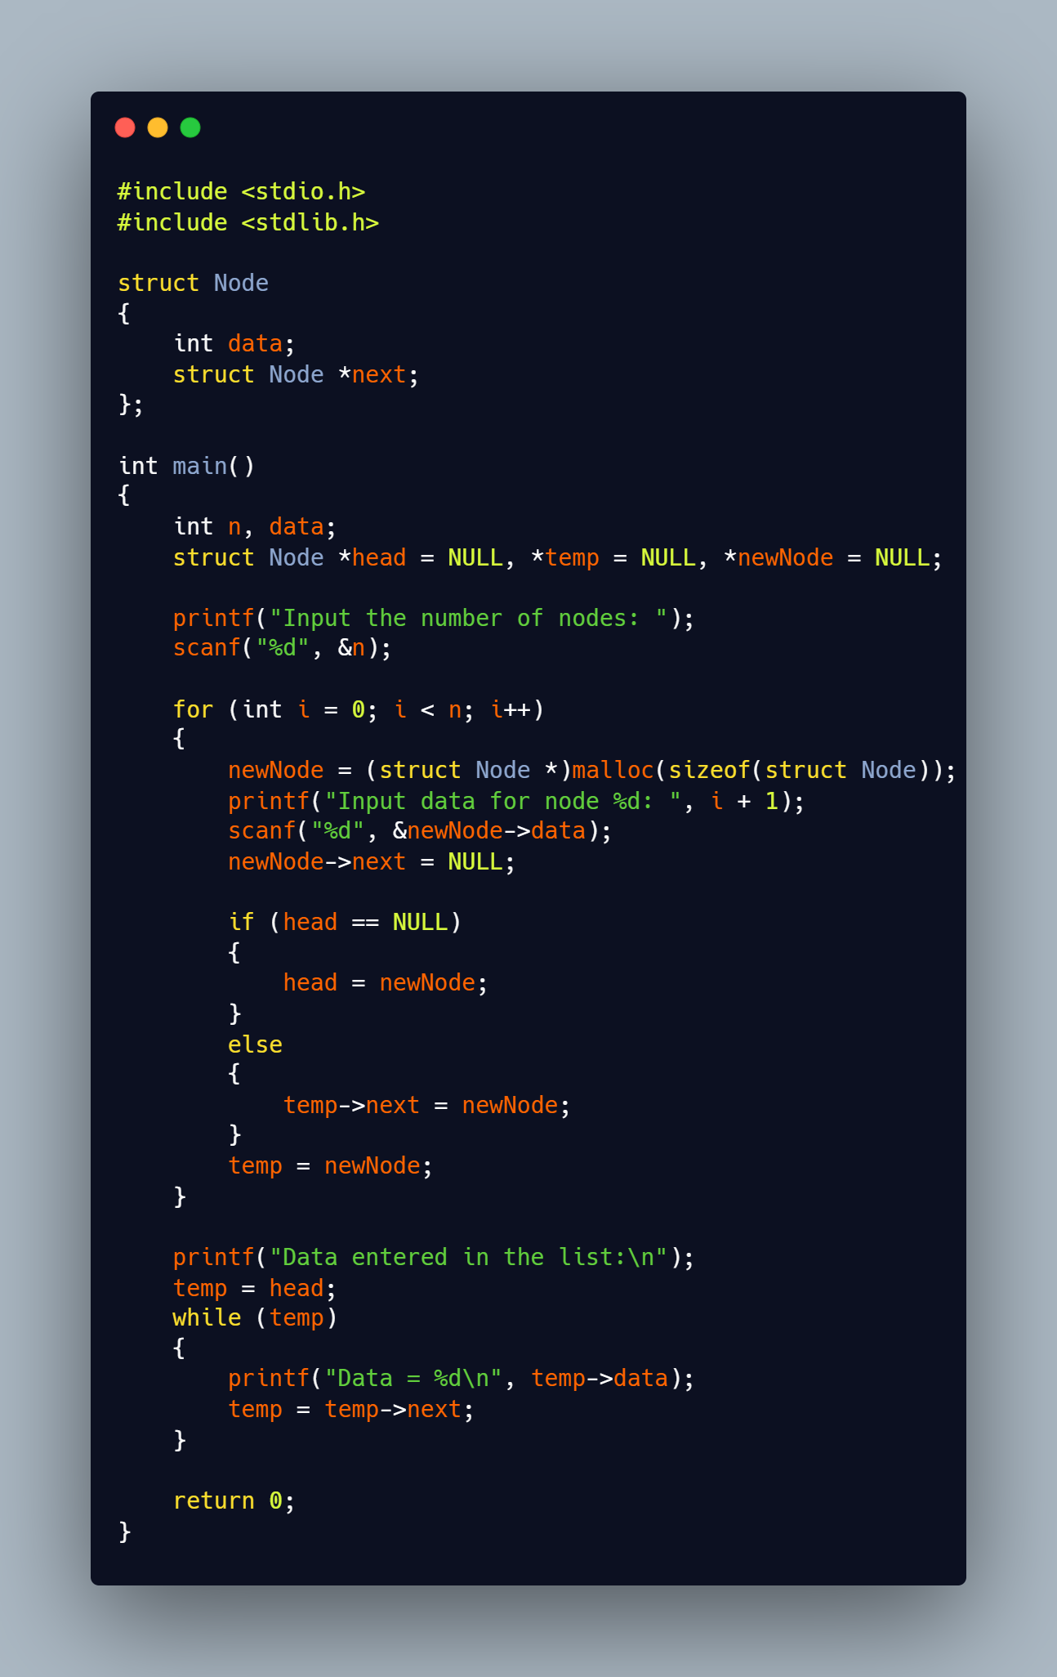

**Output:**

